**Web-based Ordering & Ingredient Estimating for Bakery Manufacturer**

Project Proposal

By

**Miss. Nontra Nonsee 542115026**

**Mr. Parinya Panyanak 542115034**

Department of Software Engineering

College of Arts, Media and Technology

Chiang Mai University

Project Advisor

________________________

**Mr.Phudinan Singkhamfu**

**Document History**

|  |  |  |  |  |  |  |
| --- | --- | --- | --- | --- | --- | --- |
| **Document Name** | **Version** | **Status** | **Date** | **Viewable** | **Reviewer** | **Responsible** |
| **Documents** | | | | | | |
| Web-based Ordering & Ingredient Estimating for Bakery Manufacturer – Project Proposal_V.0.1.docx | V.0.1  - Add Chapter 1  - Add Chapter 2  - Fix inappropriate word | Drafted | 07-02-2015 | NN, PP, PS | NN, PP | NN, PP |
| Web-based Ordering & Ingredient Estimating for Bakery Manufacturer Proposal V.0.2.docx | V.0.2  - Adjust Chapter 2  - Adjust Project Name  - Fix inappropriate word | Drafted | 14-02-2015 | NN, PP, PS | NN, PP | NN, PP |
| Web-based Ordering & Ingredient Estimating for Bakery Manufacturer – Project Proposal_V.0.5.docx | V.0.5  - Adjust Development Tools  - Add Chapter 3  - Fix inappropriate word | Drafted | 17-02-2015 | NN, PP, PS | NN, PP | NN, PP |
| Web-based Ordering & Ingredient Estimating for Bakery Manufacturer – Project Proposal_V.0.7.docx | V.0.7  - Add Chapter 4  - Adjust Technology Review  - Adjust Schedule & Milestone  - Fix inappropriate word | Drafted | 18-02-2015 | NN, PP, PS | NN, PP | NN, PP |
| Web-based Ordering & Ingredient Estimating for Bakery Manufacturer – Project Proposal_V.0.8.docx | V.0.8  - Add Chapter 5  - Add References  - Adjust Chapter 1  - Adjust Chapter 2  - Adjust Chapter 4  - Fix inappropriate word | Drafted | 09-03-2015 | NN, PP, PS | NN, PP | NN, PP |
| Web-based Ordering & Ingredient Estimating for Bakery Manufacturer – Project Proposal_V.0.9.docx | V.0.9  - Adjust Feature  - Adjust System Architecture  - Fix inappropriate word | Drafted | 22-05-2015 | NN, PP, PS | NN, PP | NN, PP |
| Web-based Ordering & Ingredient Estimating for Bakery Manufacturer – Project Proposal_V.1.0.docx | V.1.0  - Adjust Feature  - Adjust System Architecture  - Adjust limits  - Fix inappropriate word | Released | 10-06-2015 | NN, PP, PS | NN, PP | NN, PP |
| Web-based Ordering & Ingredient Estimating for Bakery Manufacturer – Project Proposal_V.1.1.docx | V.1.1  - Adjust Chapter 1  - Adjust Chapter 2  - Adjust Chapter 3  - Adjust Chapter 4  - Fix inappropriate word | Reviewed | 18-06-2015 | NN, PP, PS | NN, PP | NN, PP |
| Web-based Ordering & Ingredient Estimating for Bakery Manufacturer – Project Proposal_V.1.4.docx | V.1.4  - Adjust Business Review  - Adjust Business Tools  - Adjust Technology Review  - Adjust Motivation  - Adjust Aims  - Adjust Objectives  - Adjust System Architecture  - Adjust Deliverables  - Adjust Limits  - Adjust Schedule  - Fix inappropriate word | Released | 29-06-2015 | NN, PP, PS | NN, PP | NN, PP |

**\*NN = Nontra Nonsee**

**\*PP = Parinya Panyanak**

**\*PS = Phudinan Singkhamfu**

**Table of contents**

**Chapter One | Introduction and Background** 5

**Chapter Two | Literature Review** 6

2.1 Business Review 6

2.2 Business Tools and Software Review 7

2.2.1 Absolute |Solutions| Application 7

2.2.2 Bakery Land System 8

2.2.3 PRIMS Software 9

2.3 Technology Review 10

2.3.1 C Sharp (C#) 10

2.3.2 ASP.NET 11

2.3.3 Cascading Style Sheets 3 (CSS3) 12

2.3.4 HTML5 13

2.4 Development Tool Review 14

2.4.1 Microsoft Visual Studio 14

2.4.2 Microsoft SQL Server 15

2.4.3 Microsoft IIS (Internet Information Service) 16

**Chapter Three | Quality Standard** 17

3.1 ISO29110 for Very Small Entity (VSE) 17

3.1.1 Project Management Process 17

3.1.2 Software Implementation Process 17

**Chapter Four | Project Plan** 18

4.1 Motivation 18

4.2 Aims 18

4.3 Objectives 18

4.4 System Architecture 19

4.5 Deliverables and Limits 23

4.5.1 Deliverables 23

4.5.2 Limits 27

4.6 Future work 27

4.7 Schedule and Milestones 27

# **Chapter One | Introduction and Background**

Formerly, there are many problems in the bakery manufacturer. From the Phungnoi bakery workflows, they allow the wholesalers make an order of a fresh bakery products via e-mail, and the most of them use Excel form to lists their order quantity. Then the manufacturer has many operators to receive a numerous order via e-mail and convert information received to the manufacture’s form individually. After that, the manufacturer will distribute a new document form to the receiving part, withdrawing part, manufacturing part, preparing part, and delivering part. The most common issues of the Phungnoi bakery manufacturer are mistake ordering information, complication to manage the various orders, an ingredient usages at the manufacturing time, and the accurate documentation within a manufacturer. All of these problems are affecting the current workflows. The workers often use the wrong papers to cooperation with other colleagues. When the mistake occurs, the best solution is a worker will re-check order information again and responsible for a fresh bakery product replacement. As a result, both of a wholesaler and worker waste a lot of time. Moreover, the manufacturer is losing of benefits.

Nowadays, they have many technologies and tools developed for solving the problems such as order management system and e-document system. However, there are some gaps in the existing system. For an example, they cannot apply an ingredient estimation with the online ordering function. So the bakery manufacturers that have the above problems may use these technologies to solve it. The technology that very useful and accuracy obtain order request from the wholesaler. Then the ingredient estimation will be calculating an ingredient usage in each manufacturing time. Finally, the user can create a correctly report and summary statistical information to be a chart. When a worker uses reliable documents operate with the existed workflows, it will increase the manufacturer standards. The other problem is the manufacturer unable evaluate ingredients usages in the manufacturing stage. A withdrawal ingredient quantity from the warehouse is unstable and inappropriate. The manufacturer knows an actual number of a fresh bakery product after manufactured, but unknown a real ingredient amount are used. So the ingredient estimation will affect to the withdrawing stage and manufacturing stage.

With these problems, our group decides to create the Web-based Ordering & Ingredient Estimating for Bakery Manufacturer to solve previous problems. By creating the project as a web application with consists of an ordering system, product management, ingredient management, user management, ingredient estimation, and report system. The primary objective of this system is to handle the order information, control the ingredient usage for budget reduction, summary existed information to a report, and display statistical data in a chart format. We hopefully this system and all function implemented will solve the bakery manufacturer problems.

# **Chapter Two | Literature Review**

## Business Review

**Overview**

Web-based Ordering & Ingredient Estimating for Bakery Manufacturer is a web application that derived by C#, ASP.NET, HTML5, and CSS3. This system can used for helping the bakery manufacturer managing a fresh bakery orders and estimating ingredient needs to utilize in each manufacturing time. Then, it can report all information and create statistical data to be a chart. On the other hand, the system also helps the wholesaler side can make an order and handle their ordering information quickly.

**Target**

The primary target of the Web-based Ordering & Ingredient Estimating for Bakery Manufacturer is to receive the order quantity from the wholesalers to facilitate cooperation within the manufacturer. It can also be calculating ingredient quantity from the order received and utilize in each manufacturing time. Then the final output of all information in the system is a report, statistical chart and require information.

**Benefit**

* The wholesaler gets convenient to order a fresh bakery product.
* The wholesaler has a choice to handle their ordered information instantly.
* The wholesaler can know own ordered history.
* The wholesaler can analysis essential information from reports and statistical chart.
* The wholesaler can receive their order quantity accurately.
* The worker can know a summary information from order received.
* The worker can know ordered history information.
* The worker can know ingredient estimation result.
* The worker use a correct information to run a manufacturer workflow.
* The admin can control all information systematically.
* The manufacturer can control the ingredient budget in the manufacturing stage.
* The manufacturer can improve the workflow standards.
* The manufacturer increase order accuracy in the delivering stage.
* The manufacturer can analysis essential information from reports and statistical chart.

## Business Tools and Software Review

### 2.2.1 Absolute |Solutions| Application

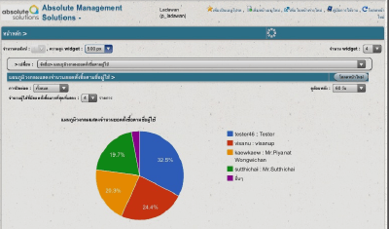

**Figure 1: Absolute |Solutions| Application Review** [1]

**Software Description**

Figure 1: This application is a business management application that using cloud computing technology to provides a server, database, and IT expert. The aims are to improve the company with better management and control tasks via the internet. The application has the wholesale and retail system, store system, and order system. [1]

**Pros**

* The application support a mobile version to facilitate a user.
* The user can save an investment data.
* The application support offline status in POS (Point Of Sale).
* The application has a notification messages to a user via SMS or email.
* The application has a reward function to collect a reward points.

**Cons**

* The application support only a manager.
* The application no has a summary function to make out a statistical data and chart.
* The application cannot integrate with the bakery manufacturer business.
* The report documentation in a system uses an excel files.
* The application no has a status tracking function.

### 2.2.2 Bakery Land System

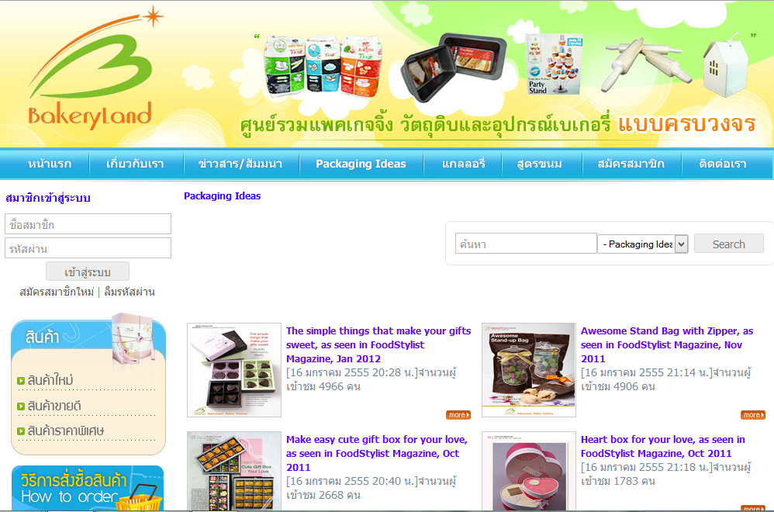

**Figure 2: Bakery Land System Review** [2]

**Software Description**

Figure 2: This website is the online ordering for trading a bakery packaging, raw material, and equipment. It has various product group and give a lot of promotion for a customer. The aims are to improve the company with better marketing by use the internet to boost sales. [8]

**Pros**

* The user can use an online ordering through the website.
* The system has a tutorial for the first order transaction.
* The system is not complicate for a general user.
* The system has board announcements from a company.
* The system provides a Thailand post link to track and trace a product.

**Cons**

* The system cannot handle after placed an order.
* The system does not provide a summary report to the customer.
* The system not collects statistical order data.
* The system does not provide an order status to the customer.
* The system displays incomplete a product information.

### 2.2.3 PRIMS Software

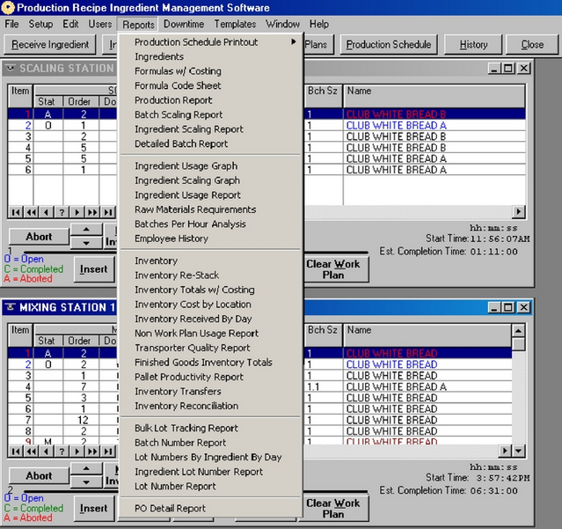

**Figure 3: PRIMS Software Review** [3]

**Software Description**

Figure 3: PRIMS stands for Production Recipe Ingredient Management Software. It is a recipe software for an ingredient controlled. It has a lot of features to support the user such as automated batching, formula control, purchasing, receiving, raw material, ingredient, goods shipping, and production planning. [3]

**Pros**

* The software has tracking system.
* The software has a production scheduling.
* The software can analysis costing.
* The software can measure ingredient usage accuracy.
* The software provides comprehensive report type.

**Cons**

* The report documentation in software uses an excel files.
* The software not summary a statistical data become to a chart.
* The software has a complicated function.
* The software only applies to an enormous factory.

## Technology Review

### 2.3.1 C Sharp (C#)

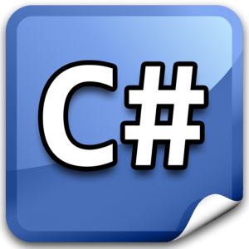

**Figure 4: C Sharp Logo** [4]

**Technology Detail**

Figure 4: C Sharp is a multi-paradigm programming language. The system uses strong typing, imperative, declarative, functional, generic, object-oriented, and component-oriented. This programming language was developed by Microsoft to run on the .NET framework. [5]

**Alternative Technology**

* C
* C++ (C Plus Plus)
* Java

**The selection of this technology**

* C# is not a complicated programming language.
* C# is support for the .NET framework.
* C# improve some defects from the existed programming language.
* C# allows bug fixes easier.
* C# supports various plugins.
* C# is easy for unit testing within itself.
* C# is support MVC pattern.

### 2.3.2 ASP.NET



**Figure 5: ASP.NET Logo** [6]

**Technology Detail**

Figure 5: ASP.NET framework is an open source tool for developing websites, web applications, and web services. It is a part of the .NET framework and developed by Microsoft. [7]

**Alternative Technology**

* PHP (Personal Home Page)
* JSP (Java Server Page)

**The selection of this technology**

* ASP.NET is support for MVC pattern.
  + ASP.NET is support for the .NET framework and C# programming language.
* ASP.NET is support for CSS.
* ASP.NET has various controls and libraries to facilitate in development.
* ASP.NET can build dynamic web applications.

### 2.3.3 Cascading Style Sheets 3 (CSS3)



**Figure 6: CSS3 Logo** [8]

**Technology Detail**

Figure 6: CSS stands for Cascading Style Sheets. CSS3 is the last version of CSS style sheets language used to design element of the website such as layout, color, size or font of the site. Then display HTML elements that presentation of web pages. [9]

**Alternative Technology**

* None

**The selection of this technology**

- CSS makes web pages look better than only HTML does.

- CSS can help to design the web flexibility.

- CSS can redesign (i.e. colors, size, fonts) with not has effect to HTML code.

- CSS3 has more feature than the old version such as Combinatory, CSS Selectors, Pseudo-elements, and Style properties.

### 2.3.4 HTML5



**Figure 7: HTML5 Logo** [9]

**Technology Detail**

Figure 7: HTML stands for HyperText Markup Language. HTML5 is a markup language that used to create a user interface for present contents that can displayed in a web browser. [10]

**Alternative Technology**

* XHTML (eXtensible HyperText Markup Language)
* XML (eXtensible Markup Language)

**The selection of this technology**

- HTML can make creating accessible sites easier.

**-** HTML allow other can access quickly.

**-** HTML make a website simple and clean.

**-** HTML was handle errors easily.

**-** HTML reduce the external plug-in such as Flash.

**-** HTML is support for local storage.

## Development Tool Review

### 2.4.1 Microsoft Visual Studio



**Figure 8: Microsoft Visual Studio Logo** [11]

**Development Tool Description**

Figure 8: Microsoft Visual Studio is an open-source program to integrated development environment for developing with .Net languages which include VB.Net, C#, and C++. It referred to developing a broad variety of software including web applications and web services that are compatible with Microsoft Windows technologies and devices. [11]

**Alternative Tool**

* Sublime
* Xamarin
* Notepad

**The selection of this tool**

* Microsoft Visual Studio is an open source program.
* Microsoft Visual Studio provide many features necessary for MVC pattern development.
  + Microsoft Visual Studio is support for .NET framework development.
* Microsoft Visual Studio is flexible for using and managing via other tools.
* Microsoft Visual Studio can visualize table relationships.

### 2.4.2 Microsoft SQL Server

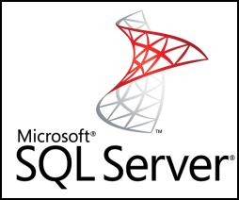

**Figure 9: Microsoft SQL server Logo** [12]

**Development Tool Description**

Figure 9: Microsoft SQL Server is an open source relational database management system that used for developing database architects. The system developed by Microsoft. This database management tool has a primary function are to store and retrieve data as requested by user. [12]

**Alternative Tool**

* My SQL Server

**The selection of this tool**

* Microsoft SQL Server is easy to integrate with Microsoft Visual Studio.
* Microsoft SQL Server provide many features support.
* Microsoft SQL Server can make more security for a database information.

### 2.4.3 Microsoft IIS (Internet Information Service)



**Figure 10: Microsoft IIS Logo** [13]

**Development Tool Description**

Figure 10: Microsoft IIS stands for Internet Information Service. The program is available on a Windows OS. It is a Web Server to services Web Suite and browsing through a web browser such as the IE(Internet Explorer), Chrome, and Mozilla Firefox. IIS can run on difference languages for an example, ASP, ASP.NET, PHP, and JSP. [14]

**Alternative Tool**

* Apache Tomcat
* AOL Server

**The selection of this tool**

* Microsoft IIS is easy to integrate with Microsoft Visual Studio.
* Microsoft IIS is flexible for using with a various web browser.

# **Chapter Three | Quality Standard**

## 3.1 ISO29110 for Very Small Entity (VSE)

ISO29110 is a guide applies to a Very Small Entity (VSE), enterprise, organisation, department or project up to 25 people, dedicated to software development. The Guide provides Project Management and Software Implementation processes. It integrate practices based on the selection of ISO/IEC 12207- *Systems and Software Engineering —Software Life Cycle Processes* and ISO/IEC 15289 - *Software Engineering – Software Life Cycle Process – guidelines for the content of software life cycle process information products (documentation)* standards elements. [15]

### Project Management Process

The purpose of the Project Management Process is to improve the success rate of projects in all areas of knowledge, which allows complying with the project’s objectives in the expected quality, time and cost. [16]

**Activities**

* Project Planning Process
* Project Plan Execution Process
* Project Assessment and Control Process
* Project Closer Process

### Software Implementation Process

The purpose of the Software Implementation process is the systematic performance of the analysis, design, construction, integration and tests activities for new or modified software products according to the specified requirements. [17]

**Activities**

* Software Implementation Initiation Process
* Software Requirements Analysis Process
* Software Architectural Design Process
* Software Construction Process
* Software Integration and Test Process
* Software Delivery Process

# **Chapter Four | Project Plan**

## Motivation

Nowadays, Phungnoi bakery manufacturer has complicated ordering information. So it is affected by the other department that must use the received order information. By the way, as the technology is growing every day, some company turn it into an advantage by using the system to help them solve the problem by managing big data in their business.

So we can use an existing order management system to fix the problem for ordering and managing information in the system. It is easy and faster ways to solve these issues. But the disadvantages of this way are online ordering cannot apply with a various department within the manufacturer Moreover it also cannot estimated the ingredient usage from the received order information. We are unable to handle it anymore even if the officer collects the statistical data to the comparison. The problems still not be fixed because the manufacturer does not know about the actual number of ingredient usage in the manufacturing time. They continue to manufacture a fresh bakery product in a same quantity, but different quality.

With above reasons, we think there must be some system to handle the problems that can help the manufacturer. They need to obtain online ordering information from a wholesaler and know accuracy number of ingredient usage for a manufacturing stage in every day. This system should able to create the report for facilitating the users, major summary information, and also has many functions to solve the above problems efficiently. Thereby resulting in “Web-based Ordering & Ingredient Estimating for Bakery Manufacturer."

## Aims

The aim of this project is to develop a web-application that provides a web-based for a wholesale side and estimate ingredient usage to the manufacturer. It should be an ordering system that receive an order information quick and easy as possible. Then also increasing the effectiveness to control their co-operation, standard, and budget.

## Objectives

* To develop a web-application for more convenience to a user.
* To support wholesaler ordering conveniently.
* To help manufacturer estimate ingredients and control usage.
* To support worker can cooperation.
* To control documents of the manufacturer easily.

## System Architecture

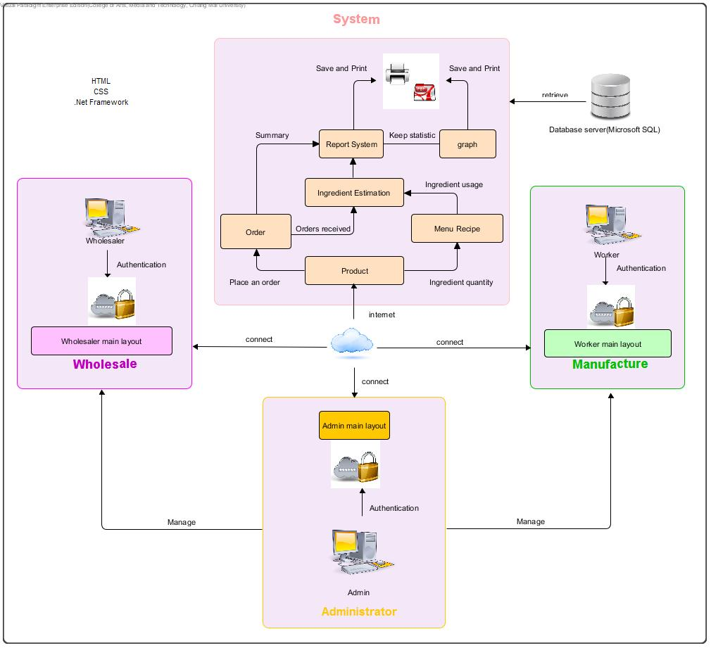

**Figure 11: Web-based Ordering & Ingredient Estimating for Bakery Manufacturer**

Figure 11: To shows the overview of the Web-based Ordering & Ingredient Estimating for Manufacturer. The system uses the internet to connect with the web application. The system provides ordering system to receive order information from the wholesaler. Then integrate to ingredient estimation and summary information into a reporting system. After that, the user can know their statistical data and preliminary analysis from a chart. The system will store all the primary information to the database management system (Microsoft SQL Server) and return again when a user sends a request. Web-based Ordering & Ingredient Estimating for Bakery Manufacturer consisted of two user sides. The first side supported a wholesaler can make an order and create their report. Another side supported an admin to control all information in the system and a worker use received information to cooperate with the other colleague.

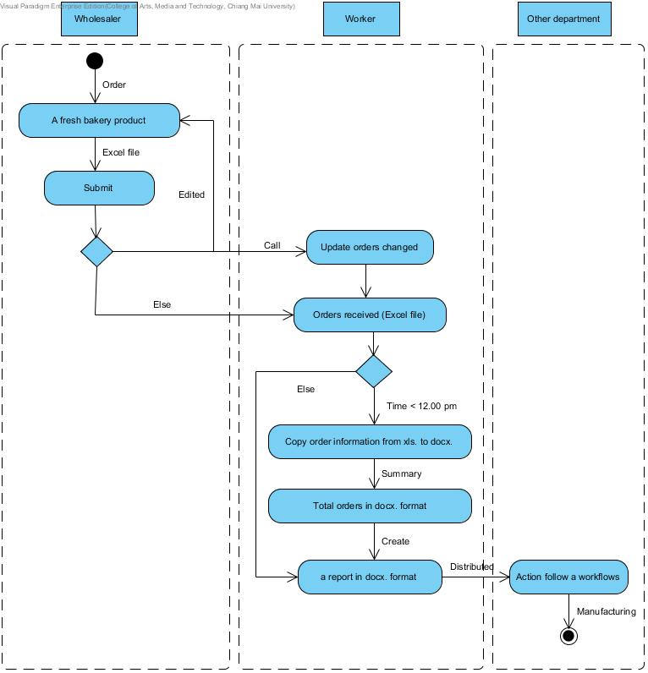

**Figure 12: Activity Diagram of an original workflow**

Figure 12: To shows the overview of the original workflow. The system separate into three part, and first the wholesaler can make an order and send to the manufacturer. If orders changed, the workers would edit an order list before utilize with the other department.

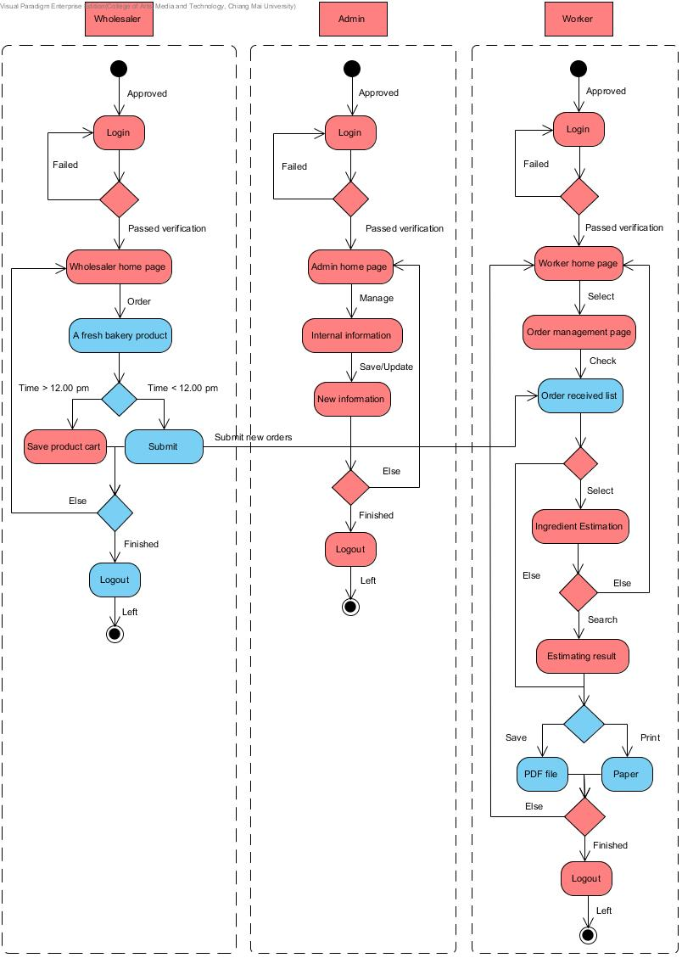**Figure 13: Activity Diagram of a new workflow**

Figure 13: To shows the overview of the Web-based Ordering & Ingredient Estimating for Bakery Manufacturer workflow. The system separate the users into three roles. First the wholesaler can make an order and also manage their order before time condition. The wholesaler can make an order at 8.00-12.00 pm every day. Else, they cannot send the request but the system will provide to save a product cart into the history. The workers would receive an order list and can apply order received with the ingredient estimation. Moreover, the both of user can create a various report follow their permission. The last user is an administrator who controls all information within the system.

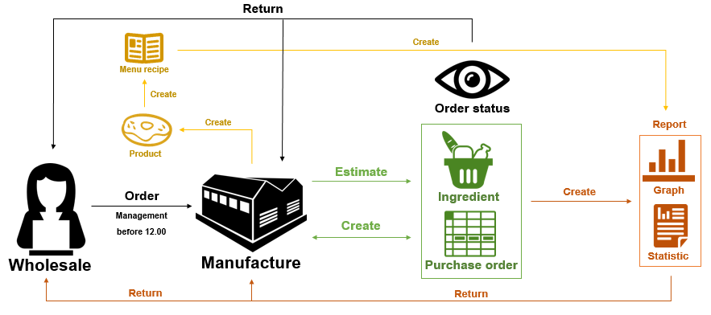

**Figure 14: Replaced system work model**

Figure 13: To shows the overview of the Web-based Ordering & Ingredient Estimating for Bakery Manufacturer work model. The wholesaler can make an order before midday. The manufacturer obtains orders and utilizes with the ingredient estimation. The system also creates a purchase order and return order status to the both of them. Then the system provides a chart and statistical data to the user. Moreover, the manufacturer can create a new bakery product and manage recipe information via the system.

## Deliverables and Limits

### Deliverables

**4.5.1.1 Progress Report I**

* **Feature#1:** User Management System

- The admin can activate a user.

**-** The admin can manage a user details by provides the username, password, first name, last name, phone number, address, and picture.

**-** The admin can display a user list.

**-** The admin can view a user details consist of the user ID, username, telephone number, address, profile picture, create date, and last sign in date.

- The member can sign in to the system.

**-** The admin can search a member details by the user ID, username, and first name.

- The member can logout from the system.

- The member can update a personal profile.

- The member can display own personal details consist of the user ID, username, telephone number, address, profile picture, create date, and last sign in date.

- The member can view own personal details consist of the user ID, username, telephone number, address, profile picture, create date, and last sign in date.

- An application provides a user management system.

* An application provides a validation message when the error occurs.

- An application provides a member details consist of the user ID, username, telephone number, address, profile picture, create date, and last sign in date.

* **Feature#2:** Product System

- The admin can manage a product details by provides the product name, product picture, category, description, and price.

- The admin can display a bakery product list such as the product ID, product name, category, product picture, and price.

- The admin can display a bakery product details consist of the product name, category, information, product picture and price.

- The member can search a bakery product details by the product ID, product name, category, and price.

- The member can view a bakery product list such as the product ID, product name, category, product picture, and price.

- The member can view a bakery product details consist of the product name, category, information, product picture and price.

- An application provides a product management system.

* An application provides a validation message when the error occurs.

- An application provides a product information consist of the product name, category, information, product picture and price.

**4.5.1.2 Progress Report II**

* **Feature#3:** Order System

- The wholesaler can order a bakery product and manage them on the time constraint.

- The wholesaler can save unfinished product cart. Then the wholesaler can return to continue their order later.

- The wholesaler can make an order by repeat ordered history information.

- The wholesaler can view a bakery product list at the summary order cart.

- The wholesaler can view the total price and discount from orders.

- The wholesaler can send a finished product cart to the system.

* The worker can view current an order details consist of the product picture, product name, quantity, price, total price, discount, delivery date, and order status.
* An application provides the current order details consist of the product picture, product name, quantity, price, total price, discount, delivery date, and order status.
* The worker can know the real-time orders.

- The worker can mark a progressive of order status in each work stage.

- The wholesaler can view own order status while an order in an action stage.

- An application provides an order management system.

* An application provides a validation message when the error occurs.

- An application provides an order details consist of the username, order date, delivery date, product picture, product name, and quantity.

* The wholesaler can search the own ordered history by the filter keywords of the order date, delivery date, product name, and order status.
* The wholesaler can view the own order history list such as the order ID, order status, product picture, order date and delivery date.
* The wholesaler can view the own order history information consist of the order ID, product name, product picture, quantity, delivery date, order date, price, total price, discount, and order status.
* The worker can search all order history by the filter keywords of the username, first name, order date, and delivery date.
* The worker can view all order history such as the username, first name, last name, order status, order date, and delivery date.
* The worker can view all order history information consist of the order ID, username, first name, last name, product name, quantity, delivery date, order date, and order status.
* **Feature#4:** Ingredient Management System
* The admin can manage ingredient details by provides the ingredient name, category, and ingredient picture.
* The admin can search ingredient details by the filter keywords of the ingredient name, and category.
* The admin can view an ingredient details consist of the ingredient ID, ingredient name, category, and ingredient picture.
* An application provides an ingredient management system.
* An application provides a validation message when the error occurs.
* An application provides an ingredient details consist of the ingredient ID, ingredient name, category, and ingredient picture.

**4.5.1.3 Progress Report III**

* **Feature#5:** Ingredient Estimation
* The admin can manage a menu recipe information by provides the ingredient name, quantity, and unit.
* The admin can search menu recipe information by the filter keywords of the product name, category, price, and ingredient name.
* The admin can view all product list.
* The admin can view a menu recipe information consist of the ingredient ID, ingredient picture, ingredient name, and category.
* An application provides a validation message when the error occurs.
* An application provides a menu recipe information consist of the ingredient ID, ingredient name, quantity, and unit.
* An application provides an ingredient estimation function.
* The worker can choose a period at a start to end for processing ingredient estimation result.
* The worker can view ingredient estimation result consist of the ingredient name, quantity, and chart.
* **Feature#6:** Report System
* The wholesaler and worker can create a report according their permission.
* The wholesaler and worker can view the report contents.
* The wholesaler and worker can save and print a report as a PDF file format.
* An application provides a report system.
* The wholesaler and worker can view a chart by choosing the filter keywords of the period.
* The wholesaler and worker can view a chart by choosing the year to show the statistical in each month.
* The wholesaler and worker can view a chart by choosing the filter keywords of the period.
* The wholesaler and worker can view a result chart consist of the chart image and statistical data.
* An application provides convert function from the existing statistical data to be a chart.

**4.5.1.4 Software Document**

* Project Proposal
* Project Management Plan
* Software Requirement Specification
* Software Design Document
* Use Case
* Use Case Description
* Class Diagram
* Sequence Diagram
* Activity Diagram
* Software Testing Document
* Test plan
* Unit Test Document
* System Test Document
* Test Record
* Unit Test Document
* System Test Document
* Software Traceability Record
* Project Progress Status Report

### Limits

- The application required the internet connection to execute.

- This application supports only the Phungnoi bakery manufacturer workflow as a sample for developing and testing the system.

- This application cannot support a stock and billing management system.

- This application cannot integrate directly with existing software.

## 4.6 Future work

* This system can support another function such as a stock management system and billing management system.
* This system can used by any manufacturer.
* This system can use other technologies to provide more convenient service.

## Schedule and Milestones

According from Figure 15 to Figure 25 was show the schedule and milestones of the Web-based Ordering & Ingredient Estimating for Bakery Manufacturer. During a period, there are work terminologies. And the description is shown below that:

**Schedule Plan:**

|  |  |  |
| --- | --- | --- |
| **Progress** | **Duration** | **Task** |
| **Proposal** | **Start:** 26 January 2015  **End:** 16 June 2015 | Proposal Document |
| **Progress I** | **Start:** 18 February 2015  **End:** 17 March 2015 | **Feature#1:** User Management  **Feature#2:** Product System |
| **Progress II** | **Start:** 18 March 2015  **End:** 30 April 2015 | **Feature#3:** Order System  **Feature#4:** Ingredient Management |
| **Final Progress** | **Start:** 02 May 2015  **End:** 02 July 2015 | **Feature#5 :** Ingredient Estimation  **Feature#6 :** Report System |
| **Publication Progress** | **Start:** 3 July 2015  **End:** 10 July 2015 | System and Document are complete |

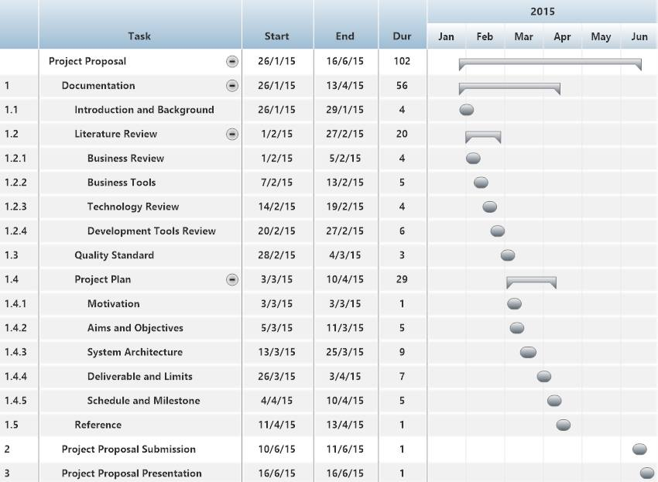

**Figure 15: Proposal Milestone**

As shown in figure 15, There are the details of each task that our have done with the documentation that represent the form of a start date, end date, and duration.

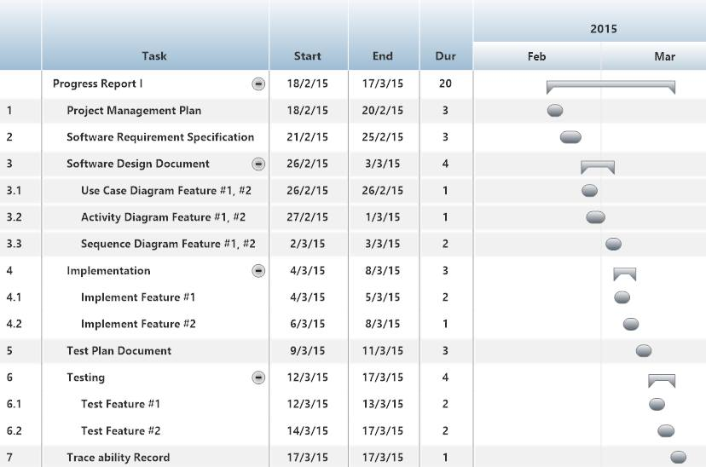

**Figure 16: Progress Report I Milestone**

As shown in figure 16, We will start develop the feature#1 and #2. We will also begin to do the development plan, quality plan, software requirement specification, software design, test plan, test record, and traceability record. It is representing the form of a start date, end date, and duration.

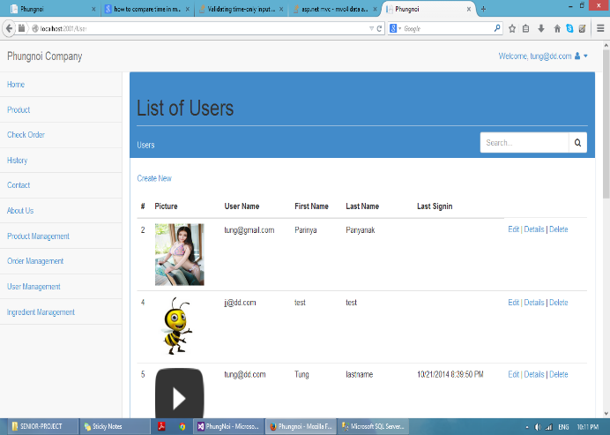 **Figure 17: User Management System Example**

As shown in figure 17, it is an example of member list page in a first feature is a User management system.

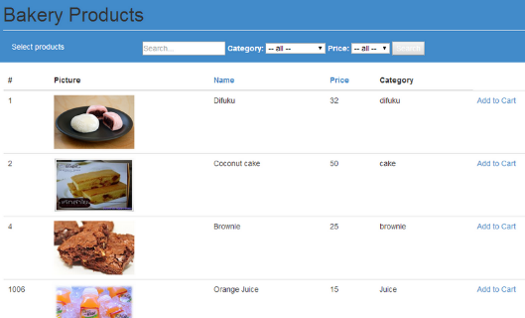 **Figure 18: Product System Example**

As shown in figure 18, it is an example of a bakery product page in a second feature is a product system.

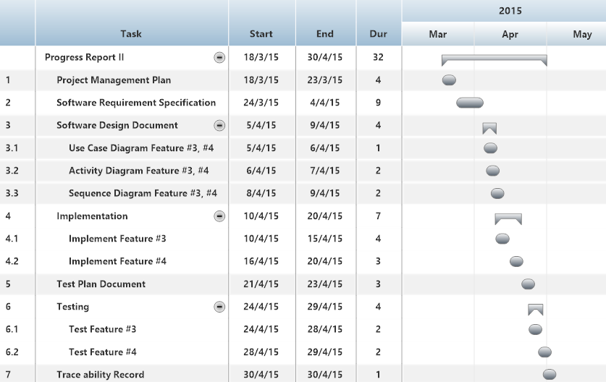

**Figure 19: Progress Report II Milestone**

As shown in figure 19, We will start develop the feature#3 and #4. We will also begin to do the development plan, quality plan, software requirement specification, software design, test plan, test record, and traceability record. It is representing the form of a start date, end date, and duration.

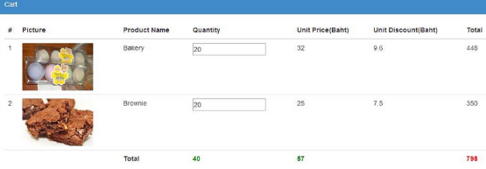  **Figure 20: Order System Example**

As shown in figure 20, it is an example of product cart page in a third feature is an order system.

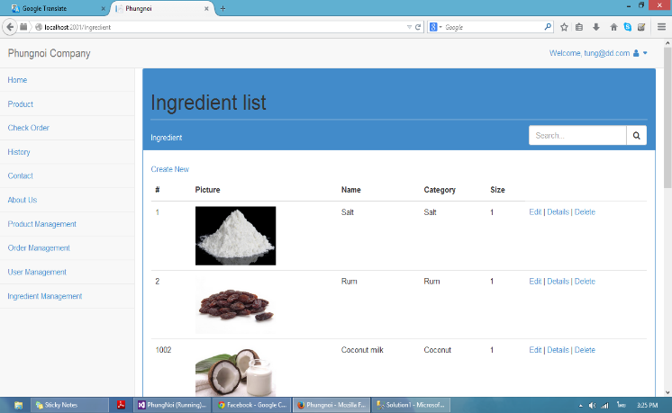

**Figure 21: Ingredient Management System Example**

As shown in figure 21, it is an example of an ingredient list page in a fourth feature is an ingredient management system.

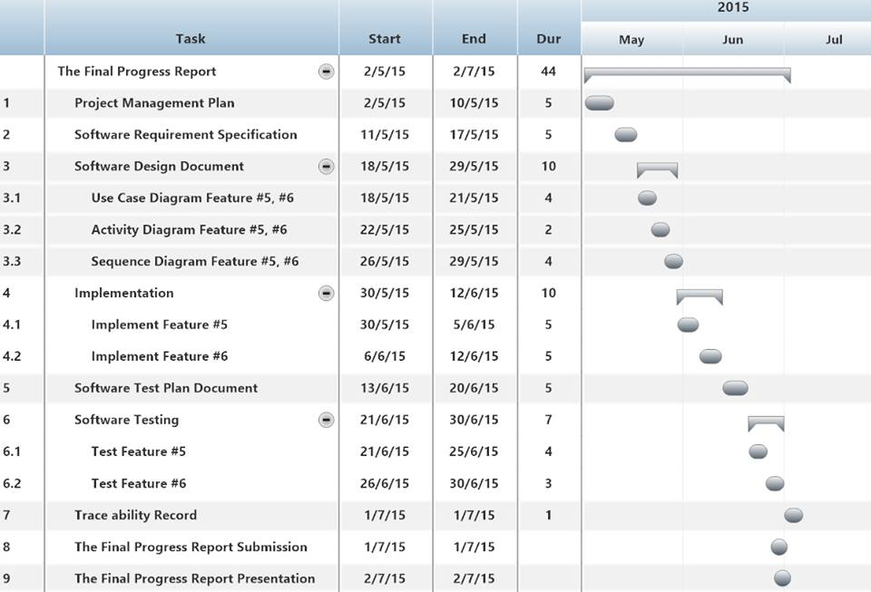

**Figure 22: Final Progress Report Milestone**

As shown in figure 22, We will start develop the feature#5 and #6. We will also begin to do the development plan, quality plan, software requirement specification, software design, test plan, test record, and traceability record. It is representing by form of a start date, end date, and duration.

**Figure 23: Ingredient Estimation Example** 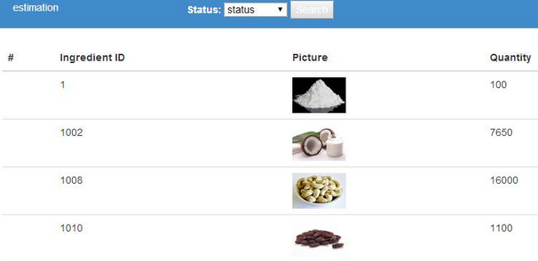

As shown in figure 23, it is an example of an ingredient estimation page in a fifth feature is an ingredient estimation system.

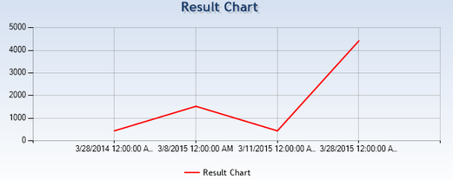 **Figure 24: Report System Example**

As shown in figure 24, it is an example of a chart page in a sixth feature is a report system.

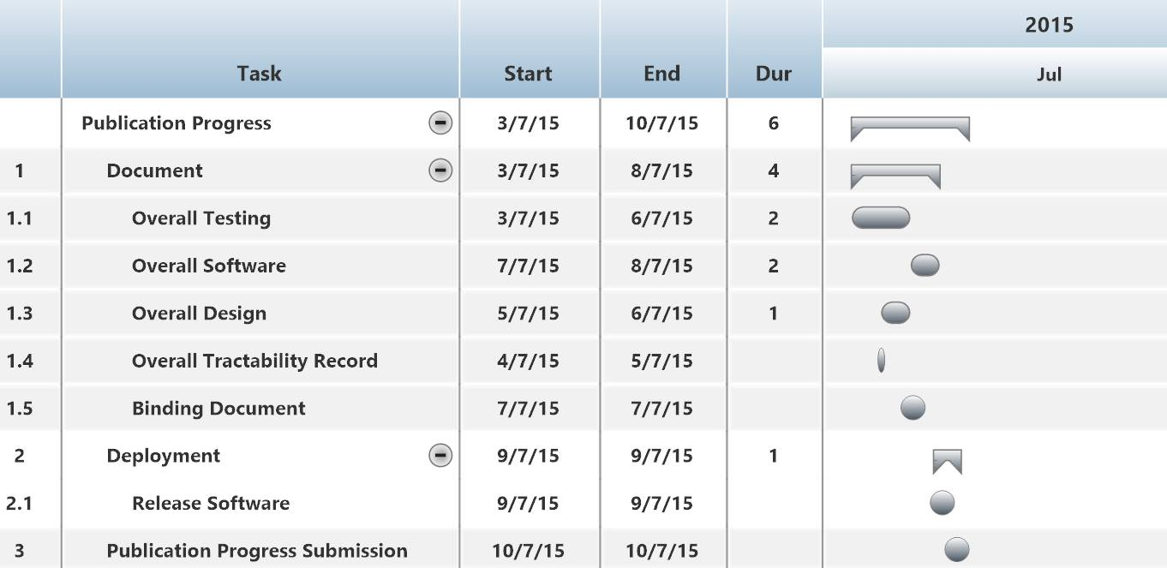

**Figure 25: Publication Milestone**

As shown in figure 25, We will start to update the development and deployment that represent the form of a start date, end date, and duration.

**Chapter Five | References**

[1] Absolute |Solutions| [Online]. Available from <https://www.absolute.co.th/index.html>

[2] Bakery land website [Online]. Available from <http://www.bakeryland.co.th/>

[3] PRIMS [Online]. Available from <http://www.focus-works.com/prims.html>

[4] Dailytwocents “Top 10 C# interview questions and answers on abstract class” [Online]. Available from <http://dailytwocents.com/top-10-c-interview-questions-answers-abstract-classes/>

[5] Wikipedia “C Sharp (Programming Language)” [Online]. Available from <http://en.wikipedia.org/wiki/C_Sharp_%28programming_language%29>

Wikipedia “HTML” [Online]. Available from <http://en.wikipedia.org/wiki/HTML>

[6] Wikipedia “ASP.NET Logo” [Online]. Available from <http://www.devwebpro.com/asp-net-open-source-cms-market-improving/>

[7] Wikipedia “ASP.NET” [Online]. Available from <http://en.wikipedia.org/wiki/ASP.NET>

[8] Microsoft “CSS3 Animations” [Online]. Available from <http://blogs.microsoft.co.il/gilf/2011/12/14/css3-animations/>

[9] Wikipedia “Cascading Style Sheets” [Online]. Available from <http://en.wikipedia.org/wiki/Cascading_Style_Sheets>

[10] Wikipedia “HTML” [Online]. Available from <http://en.wikipedia.org/wiki/HTML>

[11] Venturebeat “Microsoft debuts Microsoft Visual Studio 2015 and .NET 2015 previews” [Online]. Available from <http://venturebeat.com/2014/11/12/microsoft-debuts-visual-studio-2015-and-net-2015-previews-free-visual-studio-community-2013/>

[12] SQLmag “SQL Server 2014” [Online]. Available from <http://sqlmag.com/sql-server-2014/sql-server-2014-rtm-announced-april-1-general-release>

[13] Digicert “IIS Logo” [Online]. Available from <https://www.digicert.com/ssl-certificate-renewal-iis-7.htm>

[14] Thaicreate “Knowledge: IIS (Internet Information Service)” [Online]. Available from <http://www.thaicreate.com/web-host/web-host-iis.html>

[15] Wikipedia “ISO 29110” [Online]. Available from <https://en.wikipedia.org/wiki/ISO_29110>

[16] Wikipedia “Project Management Process” [Online]. Available from <http://en.wikipedia.org/wiki/Project_Management_Professional>

[17] “Software Implementation Process” [Online]. Available from <http://profs.etsmtl.ca/claporte/english/VSE/VSE-Gen-Profile.html>